Harmonising the Harmonic Minor Scale – Key of B
The Harmonic Minor Scale is a particularly recognisable scale. It has a very distinctive ‘Arabian Nights’ sound and is well used in many styles including Latin jazz or metal. The point of this lesson is to show how to build chords using only the notes in the harmonic minor scale. Being able to recognize these chords together in progressions or as part of progressions should hopefully then inspire you to try using the harmonic minor scale over them to improvise with.
To explain where the characteristic sound comes from let’s first look at the Natural Minor Scale as a starting point. The scale formula for the natural minor is 2 1 2 2 1 2 2 (explanations covered in a previous lesson). For a bit of a change, we can work in the Key of B:
B C# D E F# G A (B)
The natural minor harmonises to create the chords:
Bm7 - B D F# A
C#m7b5 - C# E G B
Dmaj7 - D F# A C#
Em7 - E G B D
F#m7 - F# A C# E
Gmaj7 - G B D F#
A7 - A C# E G
The difference between the above scale harmonisation and the harmonic minor is that what was once a minor 7th becomes a major 7th – A becomes A#. The new formula therefore is: 2 1 2 2 1 3 1
B C# D E F# G A# (B)
As with previous scale harmonisations, we are essentially stacking scale tones on top of each other. We begin with the scale starting from B on the 5th string because it is the root note and is in a convenient place for expanding horizontally. We are then hoping to stack the 3rd, 5th and 7th on the next 3 strings in a fingering position that is comfortable and also logical. From the first chord, we move along the scale on each string note by note to create the other remaining chords. It’s probably best to physically see and play it:

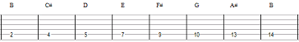
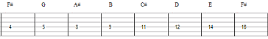
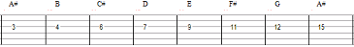
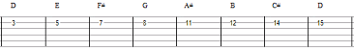
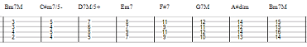
Chord names that may be ambiguous:
Bm7M = B minor 7 Major or Bmin/maj7
C#m7/5- = C#m7b5 (C# min flat 5)
D7M/5+ = DMaj7 with augmented 5th or Dmaj7#5
A#dim = A# diminished (flat 3rd, flat 5th flat minor 7th or bb7th) A#dim7
G7M = Gmaj7

So to avoid too much confusion, the chords are:
Bmin/maj7 - B D F# A#
C#min7b5 - C# E G B
Dmaj7#5 - D F# A# C#
Emin7 - E G B D
F#7 - F# A# C# E
Gmaj7 - G B D F#
A#dim7 - A# C# E G

Some progressions to try are:
Bm | Em| A#dim|Bm*
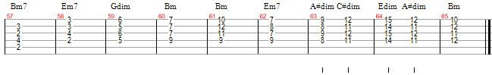
*Some of the notes in the chords are a matter of personal taste. For example, Bmin/maj7 can be substituted with Bm7, but do experiment with adding the maj7 in improvisations just to hear whether you like it on some level.
Or also
Em7 | F#7 | Gmaj7| Gmaj7 | Em7 | A#dim | F#7 | Bm
Jam these with your band/backing track/Band in a Box and practice your harmonic minor scale. Look for at least 2 more ways of playing each of the chords in the scale. Practice the natural minor over the same progressions to notice the differences etc.
Experiment with diminished chords. Note how A#dim is just another inversion of Edim, Gdim and Cdim…
When you are ready, perhaps check out the diminished scale…

